Technical Rider – Bram De Looze’s Septych

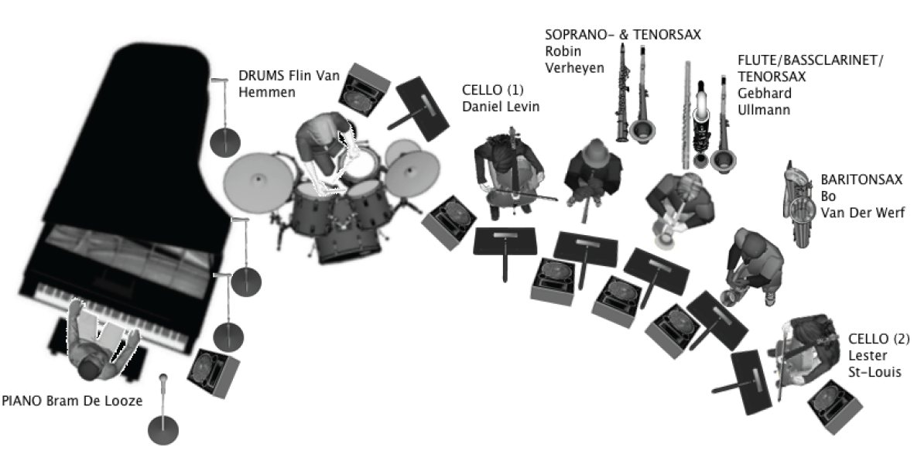

Provided by venue: monitors, microphone stands, microphones, PA, drumkit, grand piano, instrumentstands for horns (see below), 7 strong/stable music stands (2 for drums and 1 each except piano)

From left to right on stageplan above :

PIANO : BRAM DE LOOZE
PIANO LOW: CONDENSER
PIANO HIGH: CONDENSER
Presentation microphone

DRUM : FLIN VAN HEMMEN
1 Professional drum kit:
Prefer: Gretsch, Yamaha, Sonor,
or Pearl brands, w/ ‘coated ambassador’ heads
• Snare drum
(No piccolo snare please)
• 12 inch tom
• 14 inch floor tom
(Floor tom with 3-Leg hardware,
NOT as an attachment to cymbal stand please)
• 14 x 18 or 14 x 20 inch bass drum
(No larger than 20" bass drum.
Absolutely no hole in the bass drum head!)
• Bass drum pedal
• 3 cymbal stands
• Hi-hat stand
• Snare drum stand
• Throne (seat)
• Area floor rug for drum kit

Drummicrophones:

BASS DRUM: AKG D114
SNARE / HI HAT: SM 57
OVER HEAD LEFT: CONDENSER
OVER HEAD RIGHT: CONDENSER

CELLO (1) : DANIEL LEVIN
a combination of Neumann u47 or u87 with Schoeps mk4 or DPA 4011

SOPRAAN- & TENORSAX : ROBIN VERHEYEN
Sopranosax: condensator microphone (neumann)
Tenorsax : condensator microphone (neumann)
Stands for instruments

BASSCLARINET, TENORSAX & FLUTE : GEBHARD ULLMANN
Tenorsax : CONDENSER (AKG C 414)
Bassclarinet : CONDENSER
Flute : CLIP-ON CONDENSER FLUTE MIC
Stands for intruments

BARITONSAX : BO VAN DER WERF
Baritonsax : CONDENSER

CELLO (2) : LESTER ST-LOUIS
a combination of Neumann u47 or u87 with Schoeps mk4 or DPA 4011
Or Royer Cardioid Microphone

